Reception Homework Tasks
Autumn 2
Our topic this half term is ‘Are carrots orange?’ As part of this topic, the children will be looking at a variety of healthy foods and discovering ways to stay fit and healthy. This homework grid is a guide to some of the activities that parents and children can complete together to enhance your child’s learning at home. The order in which these are completed is up to you. Please do not feel you have to complete all of them in one go – one per week is sufficient. Be creative, but most of all have some fun and don’t forget to send us some photographs on class Dojo.

Fruit Bowl  Draw or paint a picture of a bowl of fruit like Pablo Picasso.  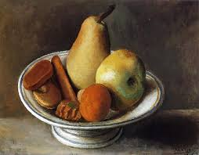 | Get Active  Go on an outdoor adventure: walk, climb, bounce.  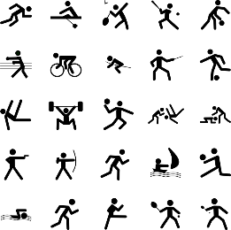  Alternatively, get active indoors: swimming, dancing or visit the soft play.  Take photographs of your experience or write a diary to share how the exercise affected your body. | Smoothie  Have a go at making a healthy smoothie for you and your family to try. Experiment with new and exciting flavours by adding fruits and vegetables.  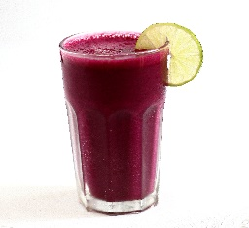  Can you write the ingredients down or make a recipe?
Where in the world?  Collect stickers or labels from healthy foods or take photographs/ cut them from magazines – where in world are they from? Can you create a world map?  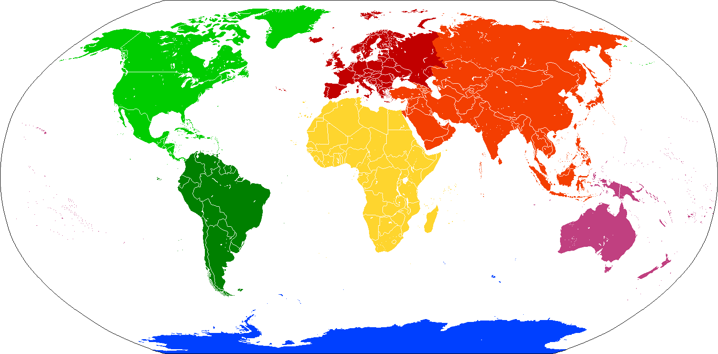 | Senses Challenge  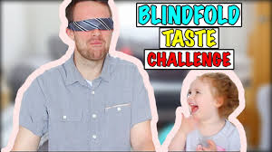  Use your senses! Ask an adult to blindfold you. They should then feed you some foods. You should use your sense of smell, touch and taste to work out which foods you have been given. You could take a picture or write a list of adjectives. | Card games  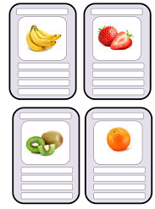Can you create cards of different foods and play snap or tops trumps? The healthier the snack the more nutrition points it would have.



Don’t forget we also have access to these online platforms too:

