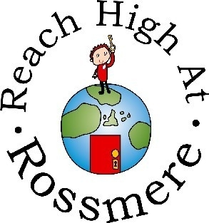

**Key People in Key Stage 1**

Mrs Anderson – Assistant Head Foundation Stage and KS1

Miss Sara Booth – Key Stage 1 Team Leader

**Key People in School.**

Mrs Caroline Reed – Head Teacher

Mrs Debbie Anderson – Deputy Head Teacher/ Designated Safeguarding Lead

Mrs Paula Hassan – Special Educational Needs Coordinator

Mrs Louise Banks – Parent Support Advisor

Rossmere Primary School

Key Stage 1

Newsletter

Date: Friday 6th January 2022

Date:

Date:

Date:

**School News in Key Stage 1:**Happy New Year to everyone in Key Stage 1!

We were glad to welcome back Mrs Collings in Year 1 just before the holidays, she returned from her maternity leave.

**Important Dates:**



|  |  |
| --- | --- |
| **Date** | **Event** |
| 04.01.22 | Spring 1 term begins |
| 18.02.22 | Break up for half term |
| 01.03.22 | Spring 2 begins |
| 08.04.22 | Easter holiday |
| 25.04.22 | Summer 1 term begins |

Year 2’s **PE** day is Tuesday.

Year 1’s **PE** day is Wednesday (Miss Collings) and Monday (Miss Reeve).

**Homework** **grids** will be sent out for Spring 1’s projects.

**The themes for this half term:**

**Year 1**

**Moon Zoom**

Moon Zoom will develop children’s knowledge of technology, space and materials. Children learn how to design and make model spaceships, considering the properties of materials. They might even meet an alien!

**Year 2**

**Muck, Mess and Mixtures**

Muck, Mess and Mixtures is a Science and Design and Technology project. The children will be learning about the properties of different everyday materials and carrying out some exciting investigations. The children will also have to exciting opportunity to pick the ingredients and make a healthy smoothie.



I think our Autumn Term was a huge success. We had so many celebrations just before the holidays; Aladdin, Christmas dinner, Christmas jumper, Christmas parties, presents, visits from Santa. We hope you have all had a lovely Christmas holiday celebrating with your families too.

**Contact Us**

School Office 274608 [admin@rossmereschool.org.uk](mailto:admin@rossmereschool.org.uk)

Head Teacher [headteacher@rossmereschool.org.uk](mailto:headteacher@rossmereschool.org.uk)

Assistant Head [kanderson@rossmereschool.org.uk](mailto:kanderson@rossmereschool.org.uk)

Team Leader [sbooth@rossmereschool.org.uk](mailto:sbooth@rossmereschool.org.uk)

**A message from our Team Leader:**I’m really looking forward to Spring 2022, the start of a new year is always exciting.

Please contact me if you have any questions and queries about anything. I am attached to everyone’s Class Dojo account.

**Great News to Celebrate!**