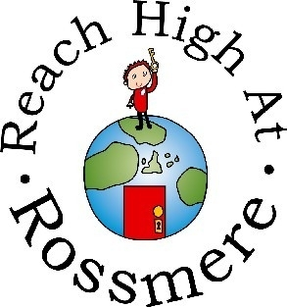

**Key People in Key Stage 1**

Mrs Anderson – Assistant Head Foundation Stage and KS1

Miss Sara Booth – Key Stage 1 Team Leader

**Key People in School.**

Mrs Caroline Reed – Head Teacher

Mrs Debbie Anderson – Deputy Head Teacher/ Designated Safeguarding Lead

Mrs Paula Hassan – Special Educational Needs Coordinator

Mrs Louise Banks – Parent Support Advisor

Rossmere Primary School

Key Stage 1

Newsletter

Date: Friday 5th November 2021

Date:

Date:

Date:

**Important Dates:**



|  |  |
| --- | --- |
| **Date** | **Event** |
| 22.11.21 | Parents evening: Week beginning |
| 29.11.21 | school is closed |
| 02.12.21 | Christmas Fair |
| 8.12.21 | Year 2 Aladdin at Billingham £20 |
| 9.12.21 | KS1 Nativity |
| 17.12.21 | Christmas Party Day |
| 17.12.21 | Christmas holiday |

Year 2’s **PE** day is Tuesday.

Year 1’s **PE** day is Wednesday (Miss Nevens) and Monday (Miss Reeve).

Year 2 will need **forest** school clothes in week beginning 8th November.  
**Reading** – please remember to read with your children three times a week.

**Homework** **grids** will be sent out for Autumn 2’s projects.

**The theme for this half term:**

**Year 1**

**Paws, Claws and Whiskers**

Our new unit is Paws, claws and whiskers the children are going to be learning all about the animals from pets in our homes to wild animals around the world.  The children are going to be learning to classify, compare and investigate animals and will even create their own new species of animal.

**Year 2**

**Beat Band Boogie**

Year 2’s new project is a music-based project. The children will be singing, playing instruments and even making instruments. They will even have the opportunity to study the artist Juan Gris and create some art in the same style as him of a musical instrument.

**School News in Key Stage 1:**Welcome to another busy, exciting half term in Key Stage 1. A few of the events to come this half term are parents evening, the Christmas fair, Key Stage 1 nativity, parties, and many more fun and exciting things have been planned for our lovely children this half term.



A very successful start to the year with the children making great progress in reading, writing and maths. The work the children have produced has been amazing with things like street houses, traffic light, dinosaur teeth and even dinosaur poo!

**Contact Us**

School Office 274608 [admin@rossmereschool.org.uk](mailto:admin@rossmereschool.org.uk)

Head Teacher [headteacher@rossmereschool.org.uk](mailto:headteacher@rossmereschool.org.uk)

Assistant Head [kanderson@rossmereschool.org.uk](mailto:kanderson@rossmereschool.org.uk)

Team Leader [sbooth@rossmereschool.org.uk](mailto:sbooth@rossmereschool.org.uk)

**A message from our Team Leader:**I’m really looking forward to Autumn 2, it’s always fun filled, stacked with glitter and twinkly lights.

Please contact me if you have any questions and queries about anything this year.

**Great News to Celebrate!**